

JAVA PROJECT REPORT ON
COURIER PARCEL TRACKING AND
DELIVERY TRACKING
SYSTEM

Submitted by
MURALI KARTHICK K
25BIT127

Under the Guidance of
MUGILAN R
Technical Trainer
Technical Department, KG College of Arts and Science

Academic Year: 2025 – 2026
APRIL 2026
Semester: I

DECLARATION
I hereby declare that the project entitled “COURIER PARCEL TRACKING AND DELIVERY STATUS SYSTEM” submitted in partial fulfillment of the requirements for the course Java programming is a record of my original work carried out under the guidance of MUGILAN R, Technical Trainer, Technical Department, KG College of Arts and Science.
I further declare that this project has not been submitted previously, either in part or in full, for the award of any degree, diploma, or other similar title, at this or any other institution.
I have acknowledged all sources of information used in this project wherever applicable.

April 2026
Coimbatore

________________________
(MURALI KARTHICK K)

CERTIFICATE
This is to certify that the project entitled “COURIER PARCEL TRACKING AND DELIVERY STSTUS SYSTEM” is a bona fide work carried out by MURALI KARTHICK .K ,B.Sc.IT ‘B’, KG College of Arts & Science, in partial fulfillment of the requirements for the course Java programming.
This project has been completed under my supervision and guidance during the academic period April 2026.

Place:
Date:

Submitted for the Viva-Voce Examination held on __________________________________

Guide: Head of the Department
(Technical Trainer, KGCAS) (Technical Head, KGCAS)

______________________ _______________________

TABLE OF CONTENTS
S. No. | Topics | Page. No.
1 | Introduction
1.1 | Objective
1.2 | Overview
1.3 | Features
2 | Program Analysis
2.1 | Problem Definition
2.2 | Project Overview
2.3 | Scopes and Limitations
3 | System Design
3.1 | Modules
4 | Methodology
4.1 | Problem Analysis
4.2 | System Design
4.3 | Program Development
4.4 | Testing and Validation
4.5 | Result and Documentation
4.6 | Algorithm
4.7 | Flowchart
5 | Source Code
6 | Input and Output Screens
7 | Discussion and Conclusion
7.1 | Discussion
7.2 | Conclusion
8 | References

ABSTRACT
The Courier Parcel Tracking and Delivery Status System is a digital solution designed to improve the efficiency, transparency, and reliability of parcel delivery services. This system enables customers and administrators to track parcels in real-time, from dispatch to final delivery, using unique tracking IDs. It provides up-to-date information on parcel location, delivery status, and estimated delivery time, thereby reducing uncertainty and enhancing customer satisfaction. The system also helps courier companies manage shipments, update delivery progress, and maintain records efficiently. By integrating modern technologies such as databases and web-based interfaces, the system minimizes manual errors, improves operational speed, and ensures secure handling of information. Overall, it offers a user-friendly and effective platform for both customers and service providers to monitor and manage courier operations seamlessly.

In today’s fast-paced world, efficient parcel tracking is essential for both customers and courier companies. The Courier Parcel Tracking and Delivery Status System is designed to provide a reliable platform for tracking parcels and managing delivery operations. The system enables users to access real-time information about their shipments, including dispatch details, transit updates, and final delivery status. It also allows administrators to maintain shipment records, update statuses, and handle multiple deliveries effectively. This system reduces delays, improves operational efficiency, and ensures transparency, making it a valuable tool in modern courier services.

The Courier Parcel Tracking and Delivery Status System is designed to help users easily track their parcels and check delivery updates online. It provides real-time information about parcel location and status using a unique tracking number. The system reduces manual work, improves accuracy, and enhances customer satisfaction by offering a fast and reliable tracking solution for courier services.

- INTRODUCTION
The Courier Parcel Tracking and Delivery Status System is developed to simplify and modernize the process of tracking parcels and managing delivery services. In the growing world of e-commerce and logistics, customers expect fast and accurate updates about their shipments. Traditional courier systems often rely on manual processes, which can lead to delays, errors, and lack of transparency. This system provides a digital platform where users can track their parcels in real time using a unique tracking ID, while administrators can efficiently manage shipment details and update delivery statuses. By using web-based technology and centralized databases, the system improves accuracy, reduces workload, and enhances communication between customers and service providers. Overall, it aims to provide a reliable, efficient, and user-friendly solution for modern courier service operations.
The rapid growth of online shopping and global trade has significantly increased the demand for efficient courier and parcel delivery services. Customers today expect real-time updates and accurate information about their shipments. The Courier Parcel Tracking and Delivery Status System is designed to meet these expectations by providing a reliable and automated tracking solution. This system allows users to monitor the movement of their parcels from the point of dispatch to the final destination using a unique tracking number. It eliminates the limitations of traditional tracking methods by offering instant updates, improved accuracy, and better accessibility. The system also enables courier service providers to manage delivery operations efficiently, maintain records, and reduce manual errors.
The Courier Parcel Tracking and Delivery Status System is a web-based application developed to enhance the efficiency and reliability of courier service operations. With the increasing demand for fast and secure delivery services, there is a need for a system that provides accurate and real-time tracking information. This system uses a centralized database to store parcel details and allows users to retrieve information through a user-friendly interface. It supports various functionalities such as parcel registration, status updates, delivery confirmation, and report generation. The implementation of this system reduces manual workload, improves data accuracy, and ensures better communication between customers and service providers. It is designed to be scalable, secure, and easy to use, making it suitable for a wide range of courier service applications.

1.1 Objective
The main objective of the Courier Parcel Tracking and Delivery Status System is to develop a simple and efficient application that automates the process of parcel tracking and delivery management using modern technologies. The system aims to provide real-time tracking information and improve the overall efficiency of courier services.
The specific objectives of this project are:
- To design and develop a parcel tracking system for courier services.
- To provide real-time tracking updates using a unique tracking ID.
- To automate the updating of parcel delivery status.
- To reduce manual errors in tracking and record management.
- To provide a user-friendly interface for customers and administrators.
- To maintain a centralized database for storing parcel and delivery details.
- To enable administrators to manage shipments and update delivery information efficiently.
- To improve transparency and communication between customers and courier service providers.
- To demonstrate the implementation of programming concepts such as database connectivity, user interface design, and data handling.
- To ensure fast, reliable, and accurate tracking services for users.

1.2 Overview
The Courier Parcel Tracking and Delivery Status System is a user-friendly application designed to simplify the process of tracking parcels and managing courier deliveries. The system allows customers to check the real-time status of their parcels by entering a unique tracking ID. It provides detailed information such as parcel location, transit updates, and delivery confirmation, ensuring transparency and reliability in courier services.
This system is developed to replace traditional manual tracking methods, which are often time-consuming and prone to errors. By using a centralized database, all parcel-related information is stored and managed efficiently. The application enables administrators to update delivery statuses, manage shipment records, and monitor the overall courier process effectively.
The system is designed with a simple and intuitive interface, making it easy for users to access tracking information without technical difficulty. It also ensures data accuracy, reduces delays, and improves communication between customers and service providers. Overall, the system enhances operational efficiency and provides a modern solution for courier parcel tracking and delivery management.

1.3 Features
The Courier Parcel Tracking and Delivery Status System provides the following key features:
- Real-Time Parcel Tracking:
Allows users to track parcels instantly using a unique tracking ID.
- Unique Tracking Number Generation:
Each parcel is assigned a unique ID for easy identification and tracking.
- Delivery Status Updates:
Provides up-to-date information such as dispatched, in transit, out for delivery, and delivered.
- User-Friendly Interface:
Simple and easy-to-use interface for both customers and administrators.
- Centralized Database Management:
Stores all parcel, customer, and delivery details in a structured manner.
- Admin Control Panel:
Enables administrators to add parcels, update statuses, and manage delivery records.
- Accurate Information System:
Reduces manual errors by automating tracking and status updates.
- Search Functionality:
Users can quickly find parcel details using the tracking ID.
- Security and Data Integrity:
Ensures safe storage and access of parcel information.
- Report Generation:
Allows generation of delivery reports and tracking history.
- Improved Communication:
Enhances interaction between customers and courier service providers.
- Time Efficiency:
Saves time by providing instant tracking updates without manual inquiry.

- PROGRAM ANALYSIS
Traditional courier systems often face issues such as lack of real-time tracking, manual record-keeping, and poor communication between customers and service providers. Customers are unable to get accurate updates about their parcel status, which leads to confusion and dissatisfaction.
Manual processes increase the chances of errors, delays, and data mismanagement. Additionally, the absence of a centralized system makes it difficult to handle large volumes of parcel information efficiently. Therefore, there is a need for an automated system that provides accurate tracking, improves efficiency, and enhances customer experience.

2.1 Problem Definition
The existing courier service systems face several challenges due to the use of manual processes and inefficient tracking methods. Customers are unable to get accurate and real-time information about the status and location of their parcels. This leads to confusion, delays, and reduced customer satisfaction.
Some common problems include:
Lack of real-time tracking for courier parcels.
- Difficulty in obtaining accurate delivery status updates.
- Dependency on manual record-keeping systems.
- Increased chances of human errors and data loss.
- Poor communication between customers and courier services.
- Inefficient handling of large volumes of parcel data.
- Lack of transparency in the delivery process.
- Delay in updating parcel information and delivery status.
- Need for a centralized and automated system.
- Requirement for a user-friendly and efficient tracking solution.
2.2 Project Overview
The Courier Parcel Tracking and Delivery Status System is developed to provide an efficient and reliable solution for tracking parcels and managing courier operations. This project focuses on automating the process of parcel tracking, reducing manual work, and improving the accuracy of delivery information.
The system allows customers to track their parcels in real time using a unique tracking ID, providing details such as current location, transit status, and delivery confirmation. For administrators, it offers functionalities to add parcel details, update delivery status, and manage shipment records through a centralized system.
The system includes the following functionalities:
The system is designed to automate parcel tracking and delivery management.
- It provides real-time tracking of parcels using a unique tracking ID.
- Customers can easily check parcel status and location details.
- Administrators can add, update, and manage parcel information.
- The system uses a centralized database to store all courier details.
- It reduces manual work and human errors in tracking.
2.3 Scopes and Limitations
Scope:
The system provides real-time parcel tracking using a unique tracking ID.
- It allows users to view delivery status, location, and updates.
- Supports administrative functions like adding parcels and updating status.
- Maintains a centralized database for efficient data management.
- Improves communication and transparency between customers and courier services.
- Can be used by small to medium courier service providers.

Limitations:
The system requires a stable internet connection to access tracking information.
- Limited to the data entered by administrators (depends on timely updates).
- Does not include GPS-based live tracking (only status-based updates).
- Security features may be basic in initial implementation.
- Not suitable for very large-scale courier networks without further enhancement.

- SYSTEM DESIGN
The Courier Parcel Tracking and Delivery Status System is designed to manage parcel tracking efficiently using a structured approach. Users can track parcels using a tracking ID, while administrators update parcel details and delivery status. The system uses a centralized database to store information and follows a client-server architecture. It includes modules like user, admin, tracking, and database modules, ensuring accurate, secure, and easy management of courier operations.
It designed to manage parcel tracking efficiently using a structured approach. Users can track parcels using a tracking ID, while administrators update parcel details and delivery status. The system uses a centralized database to store information and follows a client-server architecture. It includes modules like user, admin, tracking, and database modules, ensuring accurate, secure, and easy management of courier operations. It also improves overall system performance and reduces manual workload.

3.1 Modules
The Courier Parcel Tracking and Delivery Status System is divided into the following modules:

1. User Module
- Allows users to track parcels using a unique tracking ID.
- Displays parcel status, location, and delivery updates.
- Provides a simple and user-friendly interface.

2. Admin Module
- Enables admin to add new parcel details.
- Allows updating of delivery status (dispatched, in transit, delivered).
- Manages customer and parcel records.

3. Tracking Module
- Handles the real-time tracking process.
- Retrieves parcel information from the database.
- Displays accurate status and location details.

4. Database Module
- Stores all parcel, customer, and delivery data.
- Ensures data consistency and easy retrieval.
- Supports efficient data management.

5. Authentication Module
- Provides login access for admin users.
- Ensures security and restricted access.

6. Reporting Module
- Generates delivery reports and tracking history.
- Helps in analyzing courier performance.

7. Parcel Booking Module
- Used to register new parcels in the system.
- Stores sender and receiver details.
- Generates a unique tracking ID for each parcel.

8. Delivery Management Module
- Manages the entire delivery process.
- Assigns parcels for delivery and updates progress.
- Tracks delivery completion status.

9. Notification Module
- Sends updates to users about parcel status.
- Notifies when parcel is dispatched, out for delivery, or delivered.

10. Search Module
- Allows quick search of parcel details using tracking ID.
- Improves speed and efficiency in finding inform

13. Feedback Module
- Allows users to give feedback on courier service.
- Helps improve service quality

- METHODOLOGY
Methodology describes the process followed to develop the project. It explains the steps taken from understanding the problem to designing, implementing, testing, and documenting the system.
For the Courier Parcel Tracking and Delivery Status System, a structured development approach is followed to ensure that the system meets user requirements and performs efficiently.
The development process includes the following stages:
- Problem Analysis
- System Design
- Program Development
- Testing and Validation
- Result and Documentation
4.1. Problem Analysis
In this phase, the problem is studied and analyzed in detail. The requirements of the system are identified based on the needs of courier service operations.
The main problems identified in existing courier systems are:
- Lack of real-time tracking of parcels.
- Delay in updating parcel delivery status.
- Manual record-keeping leads to errors.
- Difficulty in managing large volumes of parcel data.
- Poor communication between customers and courier services.
Based on these problems, the system requirements were defined to develop an automated parcel tracking system that simplifies courier operations and improves efficiency.

4.2. System Design
In this phase, the overall structure of the system is designed based on the identified requirements. The system architecture, database structure, and module design are planned to ensure smooth and efficient functioning of the application.
The main design aspects of the system include:
- Designing a user-friendly interface for tracking parcels.
- Creating a centralized database to store parcel and customer details.
- Defining modules such as user module, admin module, and tracking module.
- Designing input and output formats for accurate data processing.
- Ensuring proper data flow and system security.
Based on this design, the system is structured to provide efficient parcel tracking and delivery management.

4.3. Program Development
In this phase, the actual coding of the system is carried out based on the system design. The application is developed using appropriate programming languages and tools to ensure efficient functioning of the system.
The following steps were followed during development:
- Designing and coding the user interface for parcel tracking.
- Developing the admin module to add and update parcel details.
- Implementing the tracking module to display real-time parcel status.
- Creating and connecting the database to store parcel information.
- Integrating all modules to ensure smooth system operation.
- Handling errors and ensuring proper validation of input data.
Based on these steps, the system is successfully developed to provide accurate and efficient courier parcel tracking and delivery status updates.
4.4. Testing and Validation
Testing ensures that the system works correctly and provides accurate parcel tracking information. Different test cases were used to verify the functionality of the system.
Example Test Cases:
Test Case | Expected Result
Enter tracking ID | Correct parcel details displayed
Update parcel status | Status updated successfully
Add new parcel | Parcel details stored correctly
Invalid tracking ID | Error message displayed
View delivery status | Accurate status shown
This phase ensures that the system runs without errors and provides reliable and accurate parcel tracking results.

4.5. Result and Documentation
After successful testing, the results of the system are documented. The system generates the final bill based on the selected food items and quantities.
The results are demonstrated through program execution and screenshots showing the input and output of the system.
Proper documentation is prepared to explain the design, implementation, and working of the system.
4.6. Algorithm
Algorithm for Courier Parcel Tracking and Delivery Status System:
- Start the system.
- Display the main menu (Admin / User options).
- If user selects Admin Module:
  - Enter login credentials.
  - If login is valid, allow access.
  - Add new parcel details (sender, receiver, address).
  - Generate unique tracking ID.
  - Update parcel status (dispatched, in transit, delivered).
  - Save details in the database.
- If user selects User Module:
  - Enter tracking ID.
  - Search for parcel details in the database.
  - If tracking ID exists, display parcel status and location.
  - Else display error message.
- Repeat the process until user exits.
- Stop the system.

4.7. Flowchart
Students should draw a flowchart showing program flow.
Example flow:
Start
↓
Display Menu
(Admin / User)
↓
User Choice?
/ \
Admin User
↓ ↓
Enter Login Enter Tracking ID
↓ ↓
Valid Login? Search in Database
/ \ ↓
Yes No Found?
↓ ↓ / \
Access Show Yes No
Admin Error ↓ ↓
Module Display Show Error
↓ Status Message
Add / Update
Parcel Details
↓
Save to Database
↓
Return to Menu
↓
Exit?
/ \
No Yes
↓ ↓
- SOURCE CODE

import java.util.HashMap;
import java.util.Map;
import java.util.Scanner;

class Parcel {
private String trackingId;
private String senderName;
private String receiverName;
private String status;

public Parcel(String trackingId, String senderName, String receiverName) {
this.trackingId = trackingId;
this.senderName = senderName;
this.receiverName = receiverName;
this.status = "Registered"; // default status
}

public String getTrackingId() {
return trackingId;
}

public String getStatus() {
return status;
}

public void updateStatus(String status) {
this.status = status;
}

@Override
public String toString() {
return "Parcel{" +
"Tracking ID='" + trackingId + '\'' +
", Sender='" + senderName + '\'' +
", Receiver='" + receiverName + '\'' +
", Status='" + status + '\'' +
'}';
}
}

public class CourierTrackingSystem {

private static Map<String, Parcel> parcels = new HashMap<>();
private static Scanner scanner = new Scanner(System.in);

public static void main(String[] args) {
int choice;

do {
System.out.println("\n=== Courier Parcel Tracking System ===");
System.out.println("1. Register Parcel");
System.out.println("2. Update Delivery Status");
System.out.println("3. Track Parcel");
System.out.println("4. Show All Parcels");
System.out.println("5. Exit");
System.out.print("Enter your choice: ");
choice = scanner.nextInt();
scanner.nextLine(); // consume newline

switch (choice) {
case 1 -> registerParcel();
case 2 -> updateStatus();
case 3 -> trackParcel();
case 4 -> showAllParcels();
case 5 -> System.out.println("Exiting system. Goodbye!");
default -> System.out.println("Invalid choice! Please try again.");
}

} while (choice != 5);
}

private static void registerParcel() {
System.out.print("Enter Tracking ID: ");
String id = scanner.nextLine();
System.out.print("Enter Sender Name: ");
String sender = scanner.nextLine();
System.out.print("Enter Receiver Name: ");
String receiver = scanner.nextLine();

Parcel parcel = new Parcel(id, sender, receiver);
parcels.put(id, parcel);

System.out.println("Parcel registered successfully!");
}

private static void updateStatus() {
System.out.print("Enter Tracking ID to update: ");
String id = scanner.nextLine();
Parcel parcel = parcels.get(id);

if (parcel != null) {
System.out.print("Enter new status (e.g., In Transit, Delivered, Delayed): ");
String status = scanner.nextLine();
parcel.updateStatus(status);
System.out.println("Status updated successfully!");
} else {
System.out.println("Parcel not found!");
}
}

private static void trackParcel() {
System.out.print("Enter Tracking ID to track: ");
String id = scanner.nextLine();
Parcel parcel = parcels.get(id);

if (parcel != null) {
System.out.println(parcel);
} else {
System.out.println("Parcel not found!");
}
}

private static void showAllParcels() {
if (parcels.isEmpty()) {
System.out.println("No parcels registered.");
} else {
System.out.println("All Parcels:");
parcels.values().forEach(System.out::println);
}
}
}

6.INPUT AND OUTPUT SCREENS
COMPILATION SCREEN:
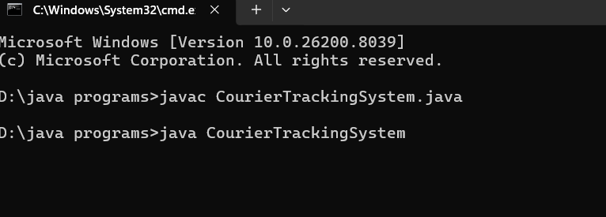

INPUT SCREEN:

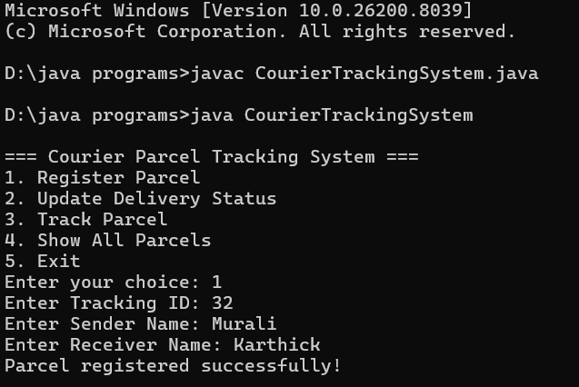

OUTPUT SCREEN:

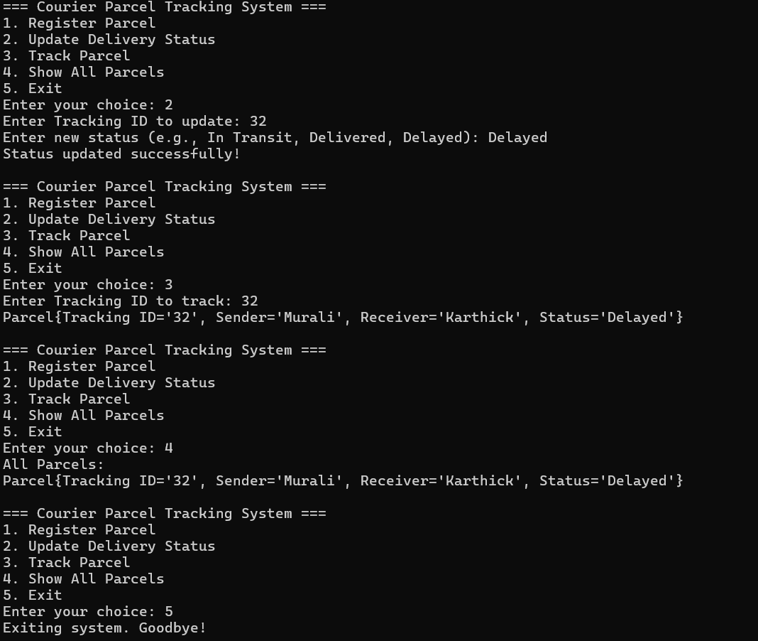

- DISCUSSION & CONCLUSION

7.1 Discussion
The Courier Parcel Tracking and Delivery Status System was developed to automate the process of tracking parcels and managing delivery status efficiently. The system allows users to enter a tracking ID and view real-time updates about their parcel, while administrators can add and update parcel details.
During the development process, programming concepts such as loops, conditional statements, methods, and basic database operations were applied. The system successfully performs parcel tracking and displays accurate delivery status information.
The system was tested with different inputs to ensure proper functionality and accuracy. The results show that the system reduces manual effort, improves transparency, and enhances the efficiency of courier service operations.

7.2 Conclusion
The Courier Parcel Tracking and Delivery Status System successfully demonstrates the practical application of programming concepts in developing a real-world logistics application.
The system automates parcel tracking, reduces errors, and provides quick and reliable delivery status updates to users. It simplifies courier operations by maintaining organized records and improving communication between customers and service providers.
This project helps in understanding how software systems can be used to solve real-life problems. The system can be further enhanced by adding features such as GPS-based tracking, mobile application support, and advanced security mechanisms.

- REFERENCES

The following resources were used during the development of this project:
Books
• Herbert Schildt – Java: The Complete Reference
Websites
• https://www.oracle.com/java
• https://www.geeksforgeeks.org
• https://www.w3schools.com
• https://www.javatpoint.com

